Date | 30/10/2025
Time id | NM2025TMID05890
Project name | Calculating Family Expenses using Service Now
Maximum mark | 4 marks
Performance and Testing

Model performance testing
Setting up ServiceNow Instance
- Sign up for a developer account on the ServiceNow Developer site “https://developer.servicenow.com”.
- Once logged in, navigate to the "Personal Developer Instance" section.
- Click on "Request Instance" to create a new ServiceNow instance.
- Fill out the required information and submit the request.
- You'll receive an email with the instance details once it's ready.
- Log in to your ServiceNow instance using the provided credentials.
- Now you will navigate to the ServiceNow.

Creation of New Update Set
- Go to All >> In the filter search for Local Update set > click on New.
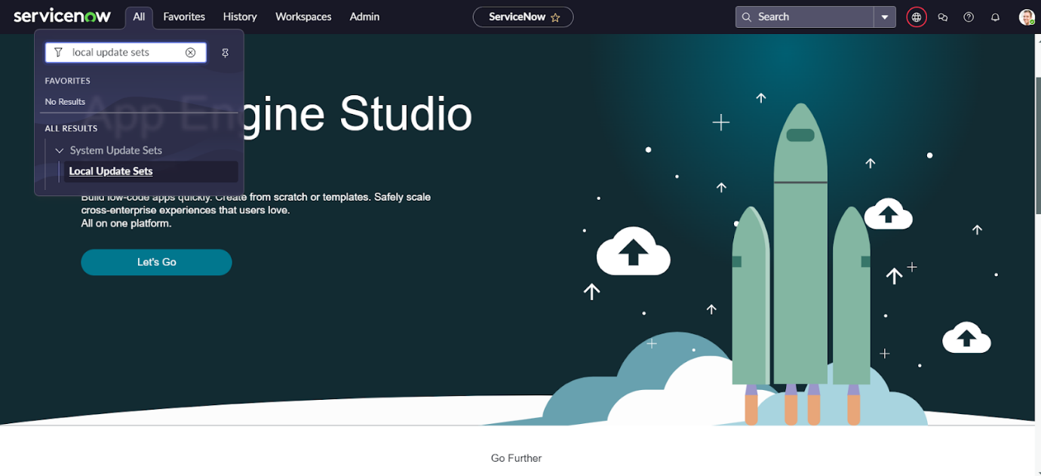
- Enter the Details as:
Name : Family Expenses
- Then click on Submit and Make current.
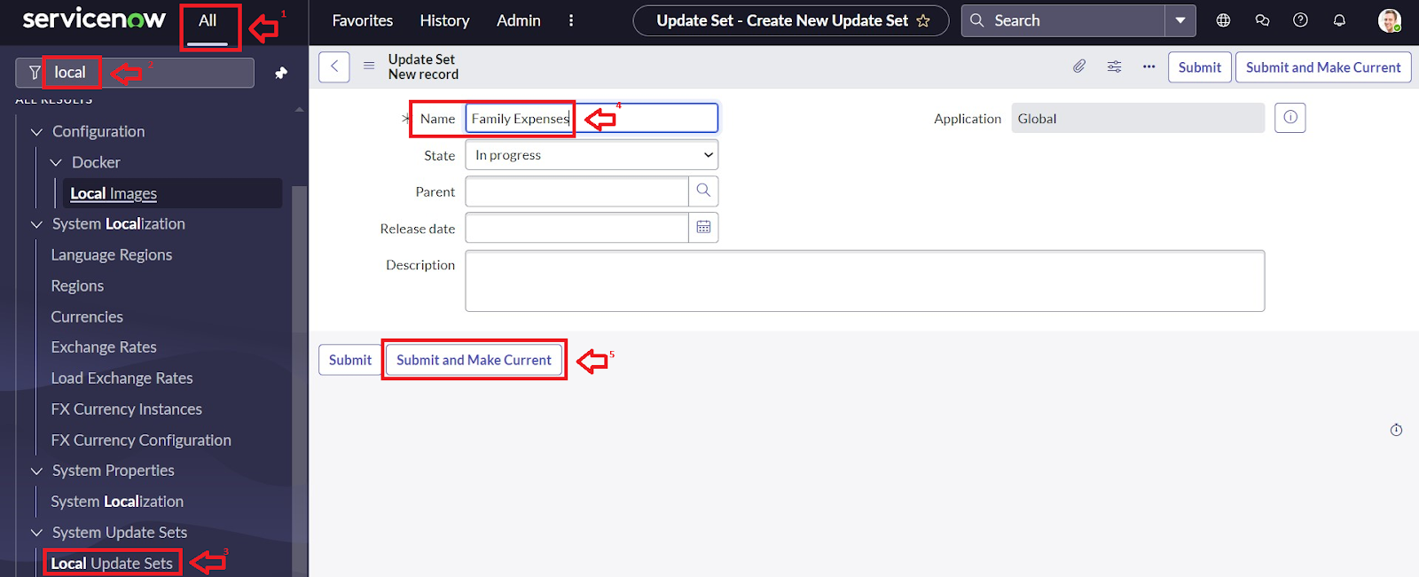

Creation of Table
- Go to All >> In the filter search for Local Update set > click on New.
- Enter the Details as:
Name : Family Expenses
- Then click on Submit and Make current.

Creation of Table
Creation of Family Expenses Table
- Go to All > In the filter search for Tables > click on New.
- Enter the Details:
Label : Family Expenses
Name : Auto-Populated
New menu name : Family Expenditure
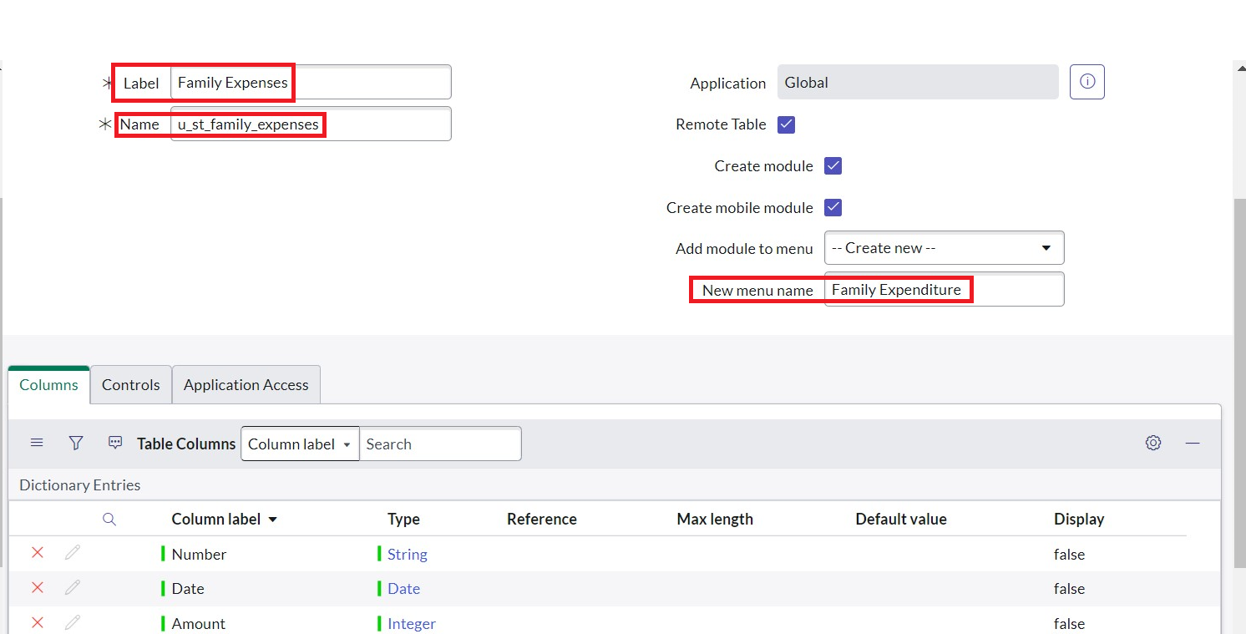
- Go to the Header and right click there>> click on Save.

Creation of Columns(Fields)
- Near Columns Double click near insert a new row.
2.Give the details as:
Column label : Number
Type : String
- Double click on insert a new row again
- Give the details as:
Column label : Date
Type : Date
- Double click on insert a new row again
- Give the details as:
Column label : Amount
Type : Integer
- Double click on insert a new row again
- Give the details as:
Column label : Expense Details
Type : String
Max length : 800
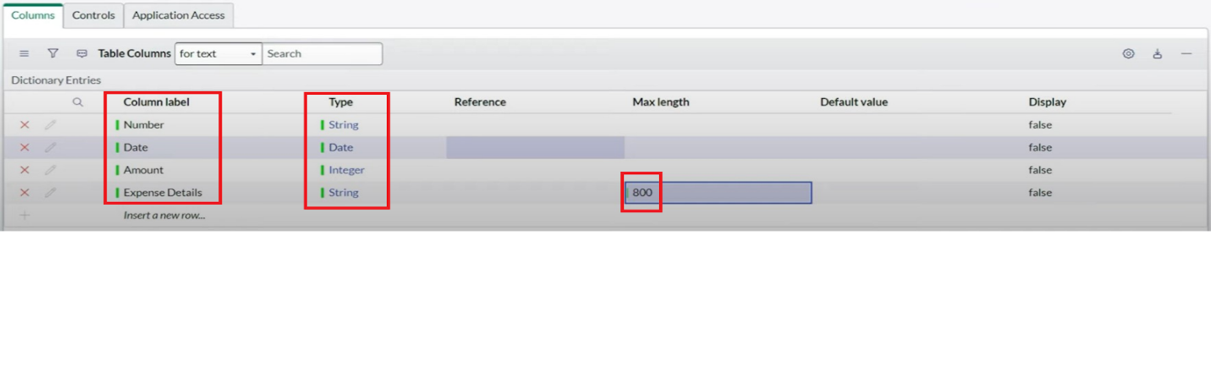
- Go to the Header and right click there>> click on Save.

Making Number Field an Auto-Number
- Double click on the Number Field/Column.
- Go down and double click on Advanced view
- In Default Value:
Use dynamic default : check the box
Dynamic default value : Get Next Padded Number
4.Click on Update.
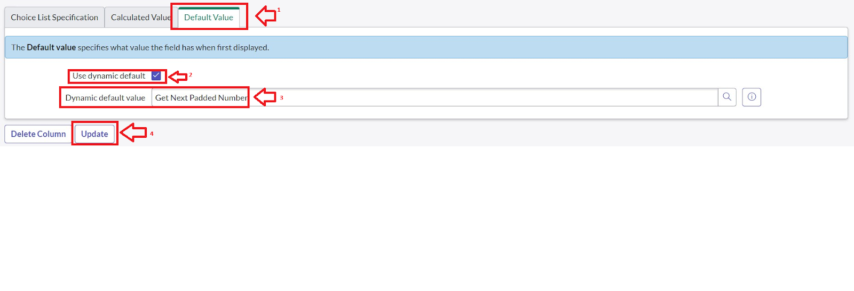
5.Go to All >> In the filter search for Number Maintenance >> select Number Maintenance
6.Click on New.
7.Enter the below Details:
Table : Family Expenses
Prefix : MFE
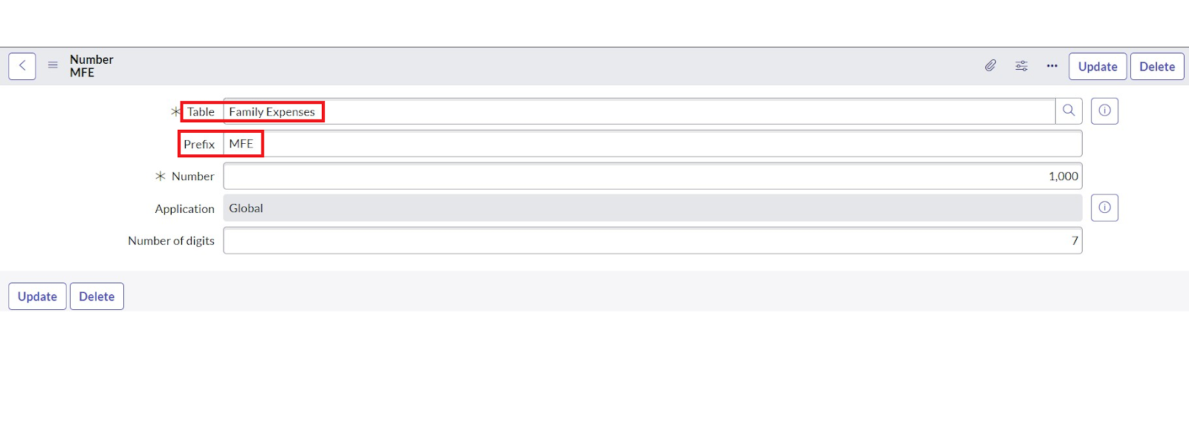
8.Click on Submit.
Configure the Form
- Go to All >> In the filter search for Family Expenses >> Open Family Expenses
- Click on New
- Go to the Header and right click there>> click on Configure >> Select Form Design
- Customize or Drag Drop the form as per your requirement.
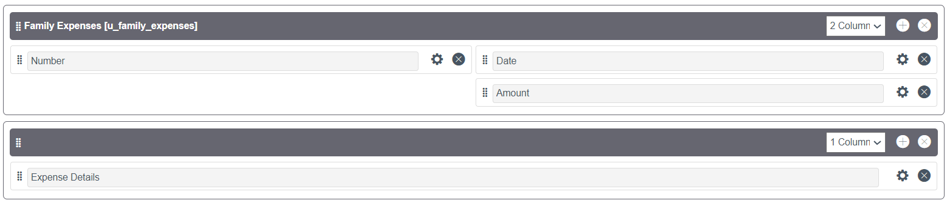
5.Make Number Read-Only Field by clicking on the gear icon and checking Read-Only
6.Make Date, Amount Mandatory Field by clicking on the gear icon and checking Mandatory
7.Click on Save.

Creation of Relationship between Family Expenses and Daily Expenses tables

- Go to All >> In the filter search for Relationships >> Open Relationships
- Click on New.
- Enter the details:
Name : Daily Expenses
Applies to table : Select Family Expenses
Daily Expenses : Select Daily Expenses
4.Click Save.
Configuring Related List on Family Expenses
- Go to All >> In the filter search for Family Expenses >> Open Family Expenses
- Click on New
- Go to the Header and right click there>> click on Configure >> Select Related Lists
- Add Daily Expenses to the Selected Area.
- Click on Save
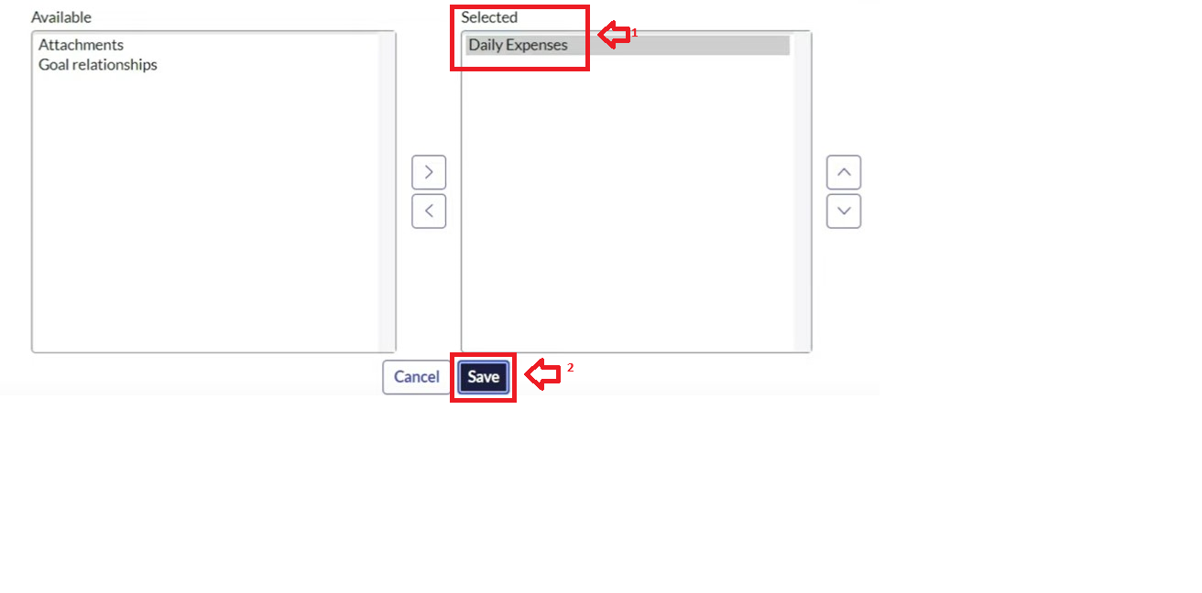

Creation of Business Rules
- Go to All >> In the filter search for Business Rules.
- Under System Definition Select Business Rules then click on New.
- Enter the Details:
Name : Family Expenses BR
Table : Select Daily Expenses
Check Advanced
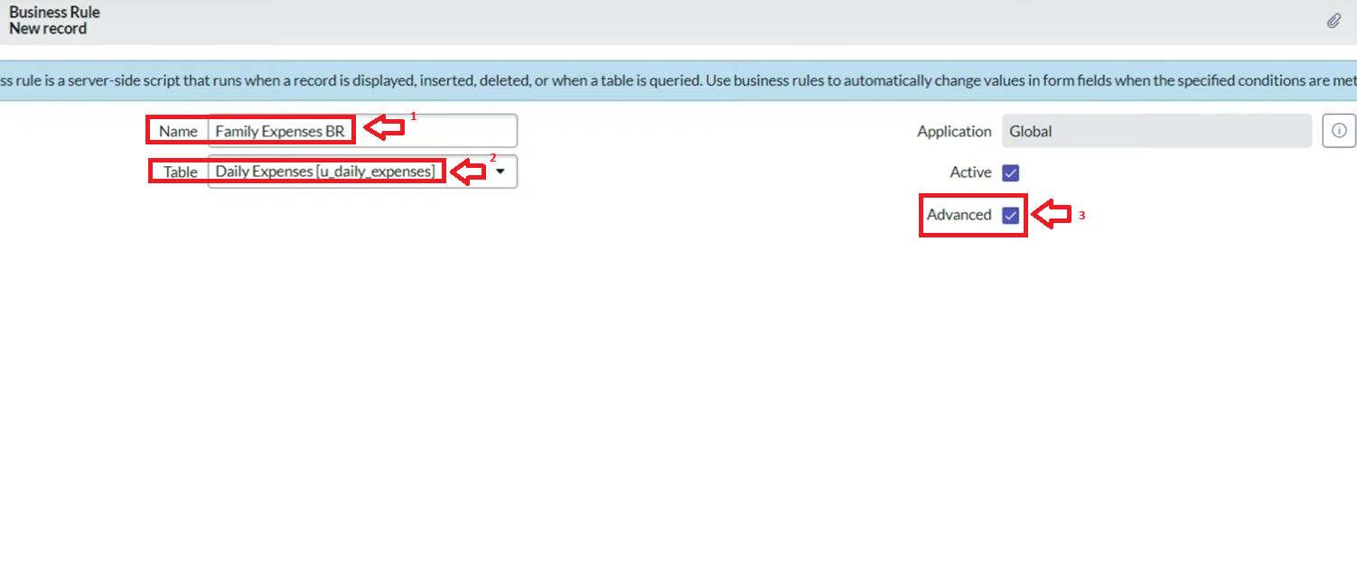
- In when to run Check Insert and Update
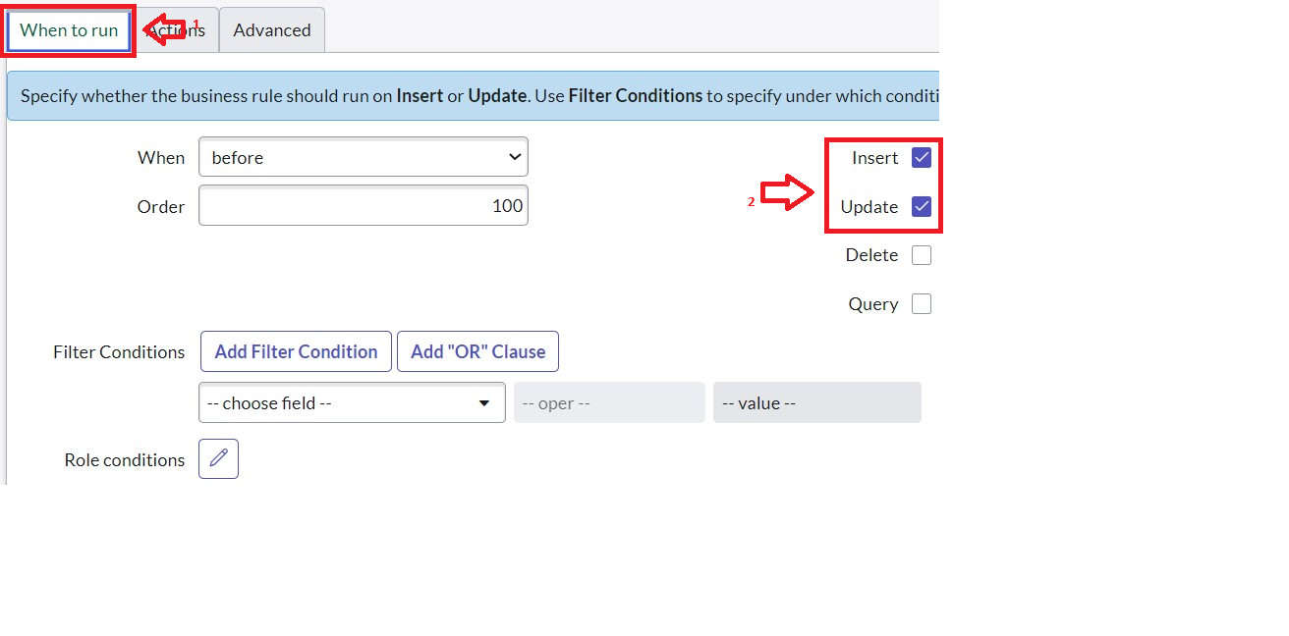
- In Advance(we write the code): Write the below code >>

(function executeRule(current, previous /*null when async*/) {

var FamilyExpenses = new GlideRecord('u_family_expenses');
FamilyExpenses.addQuery('u_date',current.u_date);
FamilyExpenses.query();
if(FamilyExpenses.next())
{
FamilyExpenses.u_amount += current.u_expense;
FamilyExpenses.u_expense_details += ">"+current.u_comments+":"+"Rs."+current.u_expense+"/-";
FamilyExpenses.update();
}
else
{
var NewFamilyExpenses = new GlideRecord('u_family_expenses');
NewFamilyExpenses.u_date = current.u_date;
NewFamilyExpenses.u_amount = current.u_expense;
NewFamilyExpenses.u_expense_details += ">"+current.u_comments+":"+"Rs."+current.u_expense+"/-";
NewFamilyExpenses.insert();
}

})(current, previous);

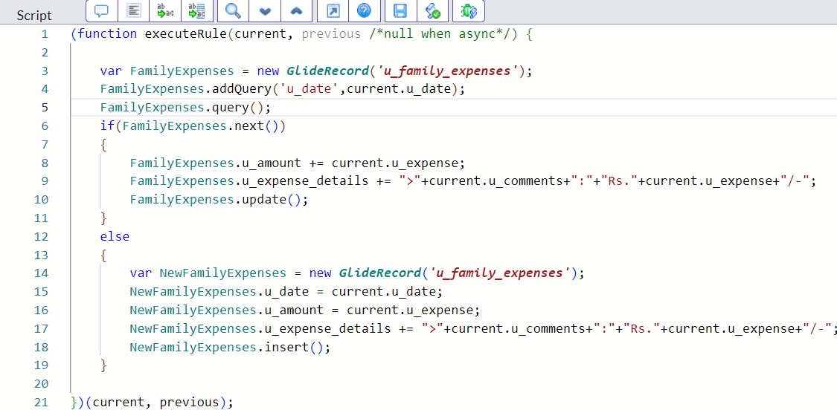

- Go to the Header and right click there>> click on Save

Configure the Relationship
- Go to All >> In the filter search for Relationships >> Open Relationships.
- In that, open Daily Expenses Relationship.
- For Applies to table : Select Family Expenses.
- In Query with : write the below Query.

(function refineQuery(current, parent) {

// Add your code here, such as current.addQuery(field, value);
current.addQuery('u_date',parent.u_date);
current.query();

})(current, parent);

- Click on Update.

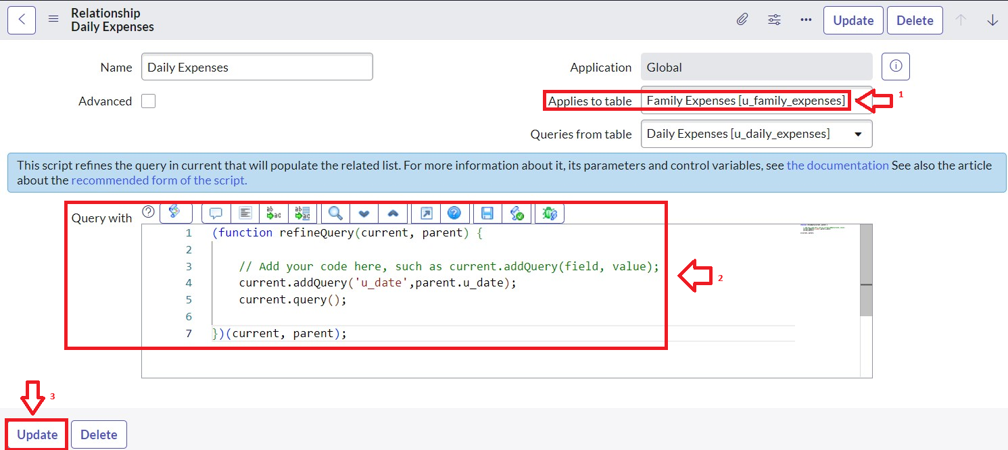

Conclusion
Calculating family expenses is fundamental for maintaining financial stability and achieving long-term goals. Accurate tracking of expenses allows families to understand their spending habits, identify unnecessary costs, and allocate funds more effectively across needs, wants, and savings. Utilizing tools or digital systems to automate this process reduces errors and saves time, enhancing transparency and collaboration among family members. Implementing a well-structured budgeting method, such as the 50/30/20 rule or envelope budgeting, empowers families to balance essential expenses with discretionary spending and savings. Ultimately, regular and thoughtful expense calculation fosters informed decision-making, reduces financial stress, and supports a secure and prosperous household financial future.

